**ASSIGNMENT-1**

Create a blog or website using Blogspot and WordPress .Customize the theme design and post new article with 500 words.

|  |  |
| --- | --- |
| NAME | S.SATHISH |
| NM ID | D3AB4E60998F2BBA802428A0FF7D9B00 |
| ASSIGNMENT 1 | Create a blog or website using Blogspot and WordPress |

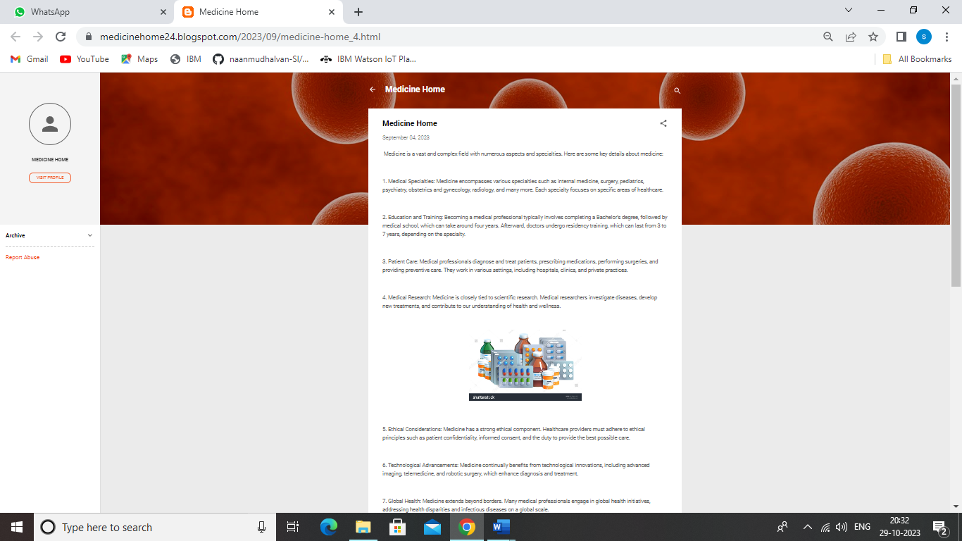

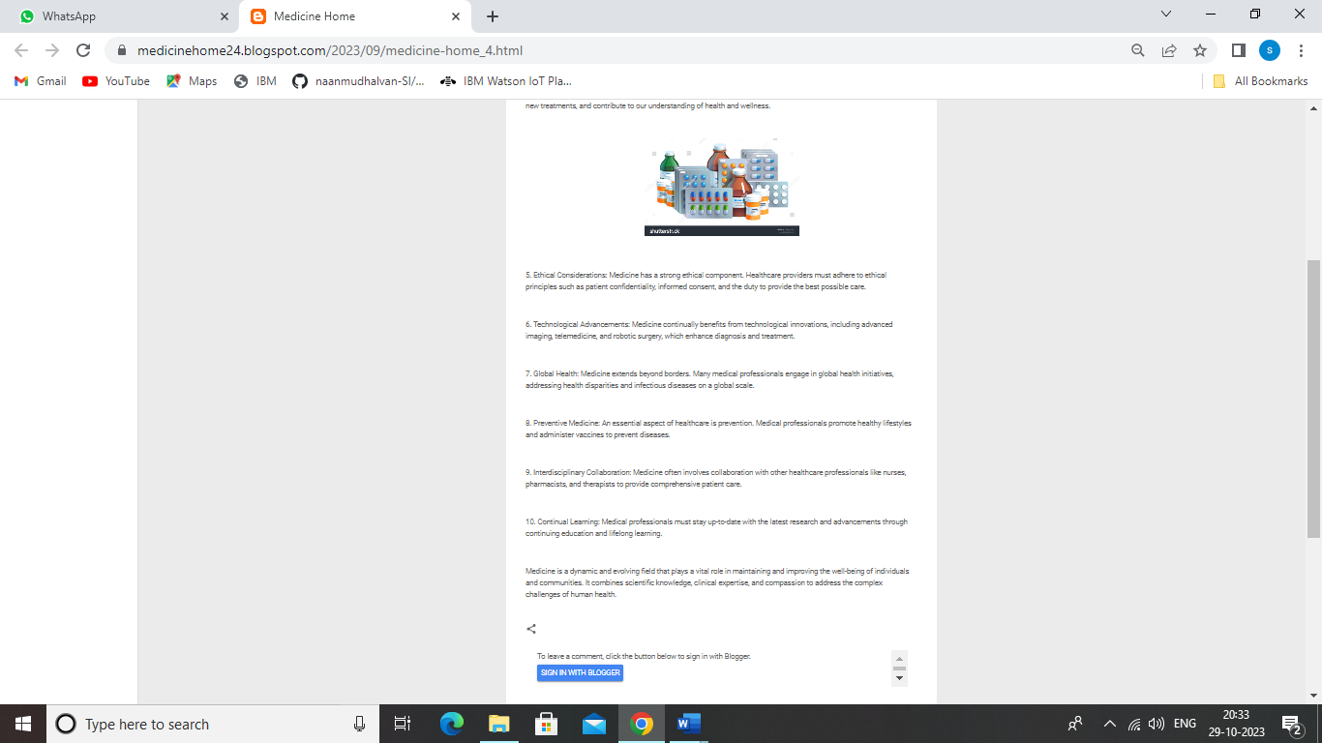

**Blog Page Link:**

<https://medicinehome24.blogspot.com/2023/09/medicine-home_4.html>

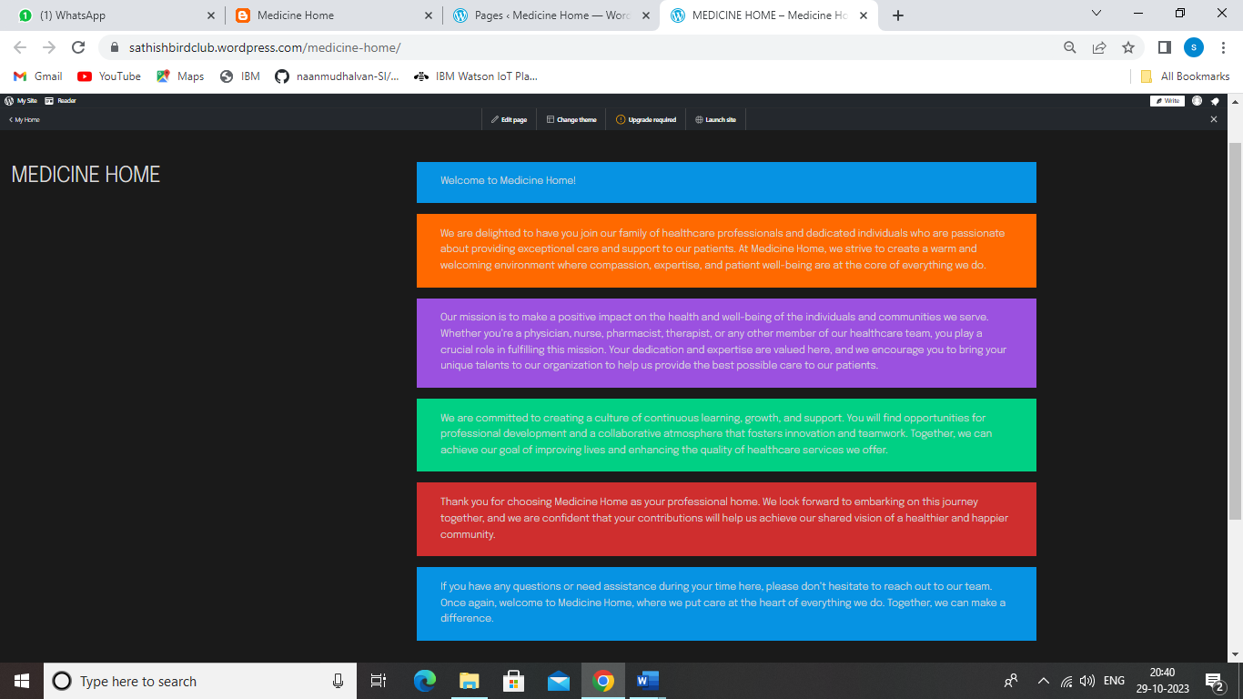

**WordPress page link:**

[**https://sathishbirdclub.wordpress.com/medicine-home/**](https://sathishbirdclub.wordpress.com/medicine-home/)